**Binding Custom Fields to an Event**

The default data fields used for event management are not a limit to the data an event can hold. You can additionally specify any number of fields you need via the storage's *CustomFields* property. If you specify custom fields, you can allow your end-users to modify field values via custom dialogs, or initialize these fields in code. With this approach you don't have to create any additional data storage to maintain extended data with individual events. More importantly, you don't have to provide any additional code to save/restore that data - it will be saved/restored with the rest of the data automatically!

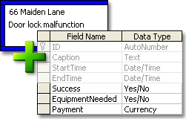

**Data Export**

As well as other controls produced by Developer Express, the *ExpressScheduler* supports data export to the following formats:

* XLS;
* HTML;
* TXT;
* XML.

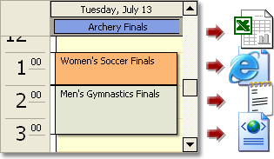

**Printing**

You can print the ExpressScheduler's content using the *ExpressPrinting System* library (sold separately). To learn more about our printing library and see the ExpressScheduler's print preview, visit the [ExpressPrinting System](http://www.devexpress.com/Products/VCL/ExPrintingSystem/) page.

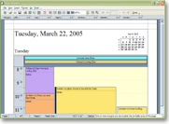

Ready to evaluate ExpressScheduler™ Suite? [Download your free evaluation copy](http://www.devexpress.com/ClientCenter/Downloads/)  
Have a pre-sales question? Email us at [info@devexpress.com](mailto:info@devexpress.com) or call +1 (818) 844-3383